1. Initial test between-list result
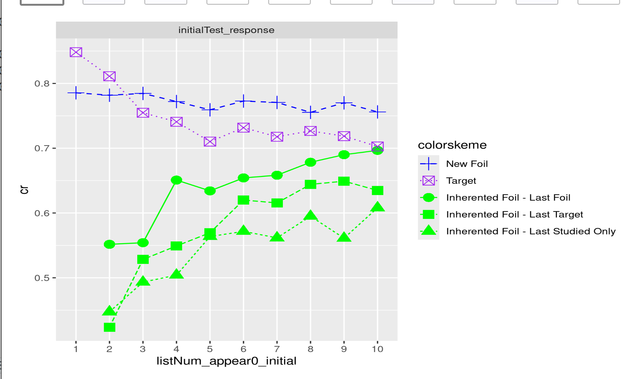

(next page)
Final Test by 2 orders (row1=Final order; row2=Initial Order)
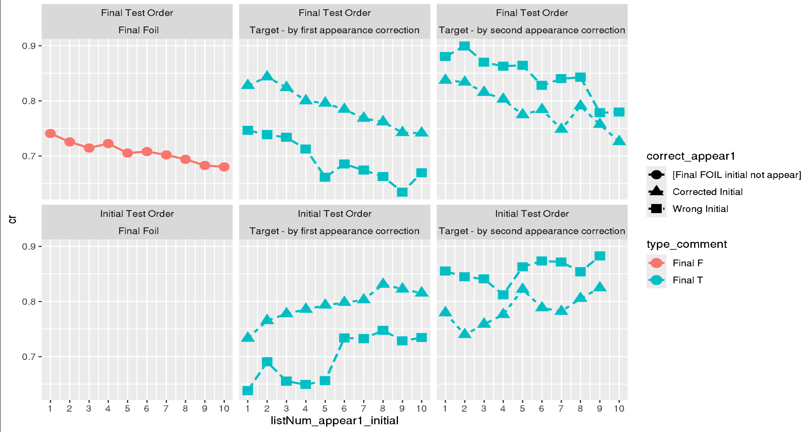
2. Final Test Between-List result (by initial test list number)

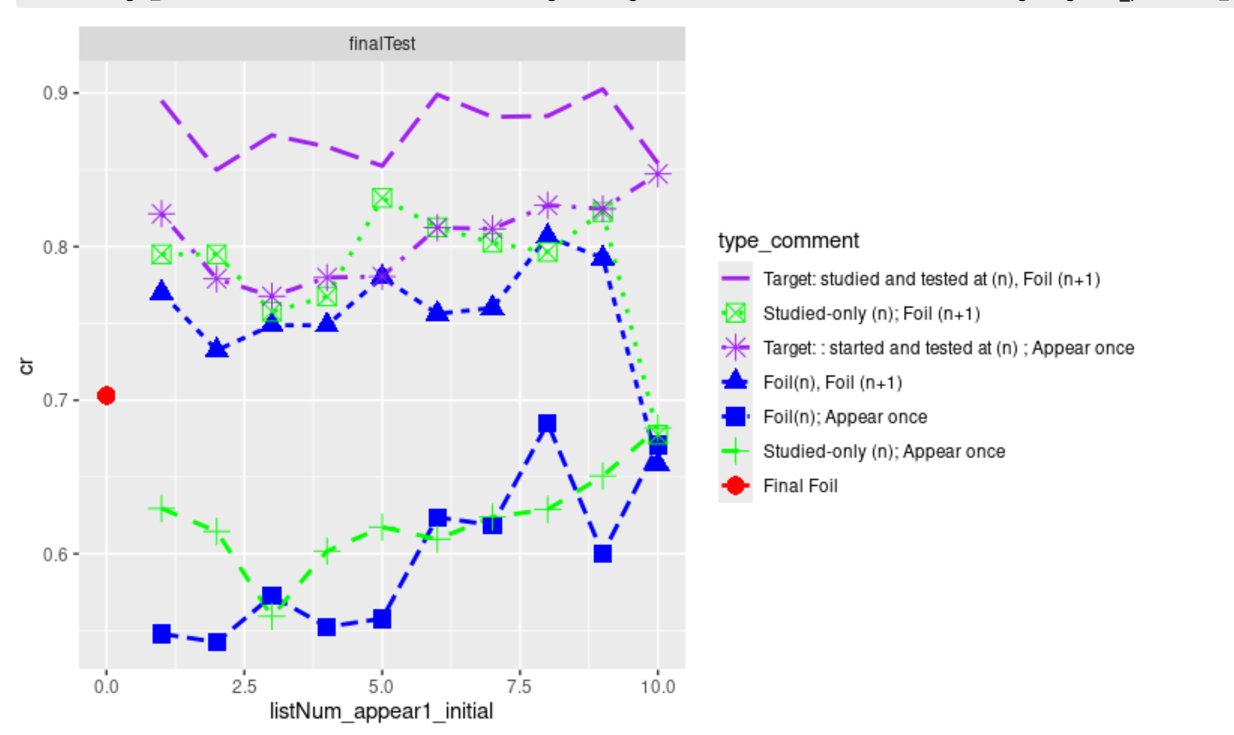
3. Final test result by Final test order
